ALG — Veeam Backup for Microsoft 365
Monthly Backup Report — 2026-01
M365 tenant: NETORG672839.onmicrosoft.com
Report generated: 2026-05-02 18:21
Executive Summary
35 M365 users in this tenant are protected by Veeam Backup for Microsoft 365. Total backup storage in use is 2.57 TB across 1 repository, with 1 active backup job. This report breaks down storage by Microsoft 365 service, lists per-user backup coverage, and projects how storage will grow over the next 12 months.
35  M365 Users | 29  Users w/ OneDrive backed up | 2.57 TB  Backup Storage Used | 1  Backup Jobs (Warning)
Backup Posture
Job | Backup Type | Last Run | Status | Enabled | Next Run
ALG-O365 | EntireOrganization | 2026-05-02T19:10:22.4492676Z | Warning | Yes | 2026-05-03T08:00:00Z
Backup repositories:
Repository | Used | Capacity | Free | Path
ALG-O365 | 2.57 TB | 3.00 TB | 442.01 GB | C:\O365 Backups\bkp_ALG-365

Storage by M365 Module
Per-module bytes are estimated by attributing the tenant's total used backup storage in proportion to how often each service appeared in restore points over the last 90 days, weighted by industry-default ratios. For exact per-mailbox / per-site sizes, run the VB365 PowerShell module (Get-VBOEntityData).
Module | Estimated Storage | Share of Total | RP coverage (last 90d)
Exchange | 1.24 TB | 48.2% | 12 / 23
OneDrive | 911.26 GB | 34.7% | 19 / 23
SharePoint | 345.32 GB | 13.1% | 12 / 23
Teams | 105.51 GB | 4.0% | 11 / 23
Per-User Backup Coverage
35 users in the M365 directory. Mailbox coverage is set Yes for every user when the job is EntireOrganization (current setting). OneDrive coverage is determined by probing /users/{id}/onedrives.
Display Name | Email | Mailbox | OneDrive
Bianca Guerrero | bianca@algrointernational.com | Yes | Yes
Leena Mallam | leena@algrointernational.com | Yes | Yes
algrointernational.com | admin@NETORG672839.onmicrosoft.com | Yes | No
Thomas Trull | thomas@algrointernational.com | Yes | Yes
Sinem Eren | sinem@algrointernational.com | Yes | Yes
Preya Patel Bhakta | Preya@algrointernational.com | Yes | Yes
Celine Lee | celine@algrointernational.com | Yes | Yes
Carolina Alves-Nijinski | carolina@algrointernational.com | Yes | Yes
Diana Trujillo | diana.t@algrointernational.com | Yes | Yes
Humberto Muñoz Rojas | humberto@algrointernational.com | Yes | Yes
Deepak Bansal | Deepak@algrointernational.com | Yes | Yes
Patricia Quezada | patricia@algrointernational.com | Yes | Yes
Technijian Support | technijian@algrointernational.com | Yes | Yes
Alicia Martinez | alicia@algrointernational.com | Yes | Yes
Penny McNerney | Penny@algrointernational.com | Yes | Yes
Paola Pruitt | paola@algrointernational.com | Yes | Yes
Diana DAgostino | Diana@algrointernational.com | Yes | Yes
Robert Walsky | rob@algrointernational.com | Yes | No
Jyoti Bansal | jyoti@algrointernational.com | Yes | Yes
Andrew Case | andrew@algrointernational.com | Yes | Yes
Shahrokh Pourmand | shahrokh@algrointernational.com | Yes | Yes
Dino Sarma | dino@algrointernational.com | Yes | Yes
Chrstina Nasrallah | christina@algrointernational.com | Yes | Yes
Veronica Espinoza | veronica@algrointernational.com | Yes | Yes
Najmeh Mortaji | najmeh@algrointernational.com | Yes | Yes
Fang Pan | fang@algrointernational.com | Yes | Yes
Smita Prakaitip | smita@algrointernational.com | Yes | Yes
Shelly Jain | shelly@algrointernational.com | Yes | Yes
Discovery Search Mailbox | DiscoverySearchMailbox{D919BA05-46A6-415f-80AD-7E09334BB852}@NETORG672839.onmicrosoft.com | Yes | No
Linh Tran | linh@algrointernational.com | Yes | Yes
Sunny Sark | ssark@algrointernational.com | Yes | No
Yajanny Alvarez | yajanny@algrointernational.com | Yes | Yes
Joe Browne | joe@algrointernational.com | Yes | No
Hailey Nguyen | hailey@algrointernational.com | Yes | Yes
Penny McNerney | Mcnerneypenny908_gmail.com#EXT#@NETORG672839.onmicrosoft.com | Yes | No

Storage Trend & Projection
Projection method: industry default 4% MoM (will refine after 2+ monthly snapshots). Compound monthly growth rate used: 4.00%.
Horizon | Projected Storage | Δ vs today
Today (snapshot) | 2.57 TB | —
+3 months | 2.89 TB | +328.18 GB
+6 months | 3.25 TB | +697.33 GB
+9 months | 3.65 TB | +1.09 TB
+12 months | 4.11 TB | +1.54 TB
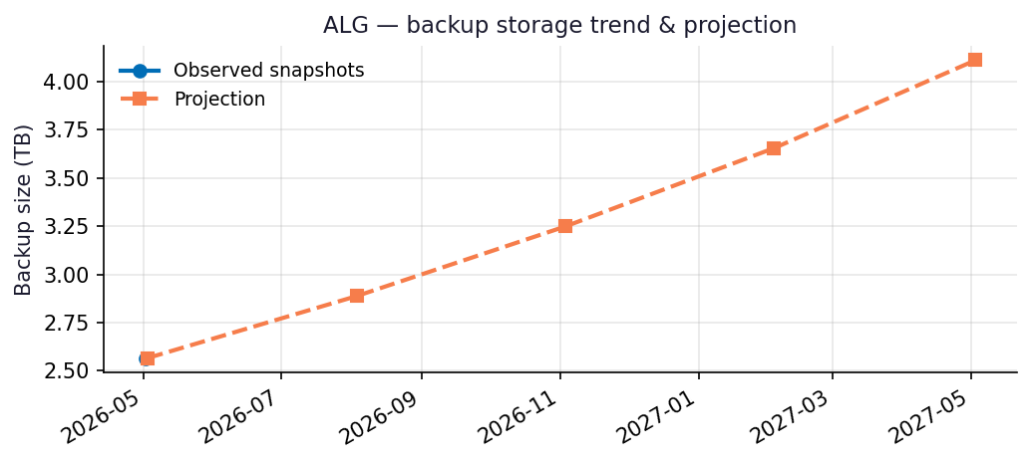
Recommendations
- Repository ALG-O365 is 86% full (442.01 GB free of 3.00 TB capacity).
- Capacity flag: Repository will hit ~90% utilization within 3 months at the current trend — begin capacity planning now.
- Run this report monthly. The projection accuracy improves with each snapshot — after 3 snapshots the linear-regression fit replaces the industry-default growth assumption.

Appendix: Methodology & Data Sources
Data sources
- Veeam Backup for Microsoft 365 REST API at https://10.7.9.227:4443/v8 (OAuth2 password grant; self-signed TLS).
- Endpoints used: /Organizations, /Organizations/{id}/usedRepositories, /Organizations/{id}/users, /Organizations/{id}/users/{uid}/onedrives, /BackupRepositories, /Jobs, /RestorePoints?backupTimeFrom=...
Per-module attribution caveat
REST does not expose per-mailbox or per-OneDrive backup byte counts on this build. Per-module estimates reweight the total used storage by the share of restore points (over the trailing 90 days) that included each service. Treat the numbers as informed estimates, not invoiced figures. For ground-truth per-user/per-team sizes use the VB365 PowerShell module Get-VBOEntityData.
Trend projection
- With <2 monthly snapshots: project at 4%/month compound.
- With ≥2 snapshots: linear regression on log(bytes) over time.

